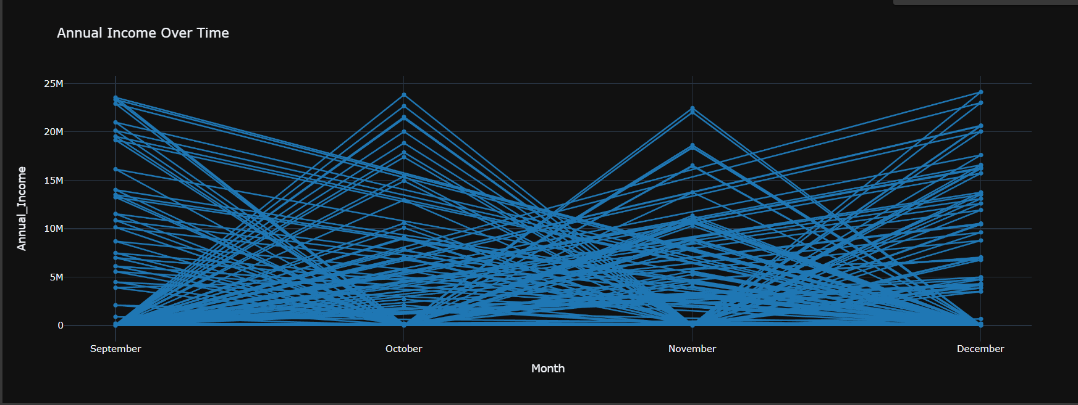

The overlapping blue lines create a densely clustered pattern, suggesting a wide distribution or variation in income levels across different entities or individuals during this time period. The peaks in October and December hint at potential seasonal fluctuations or income cycles.

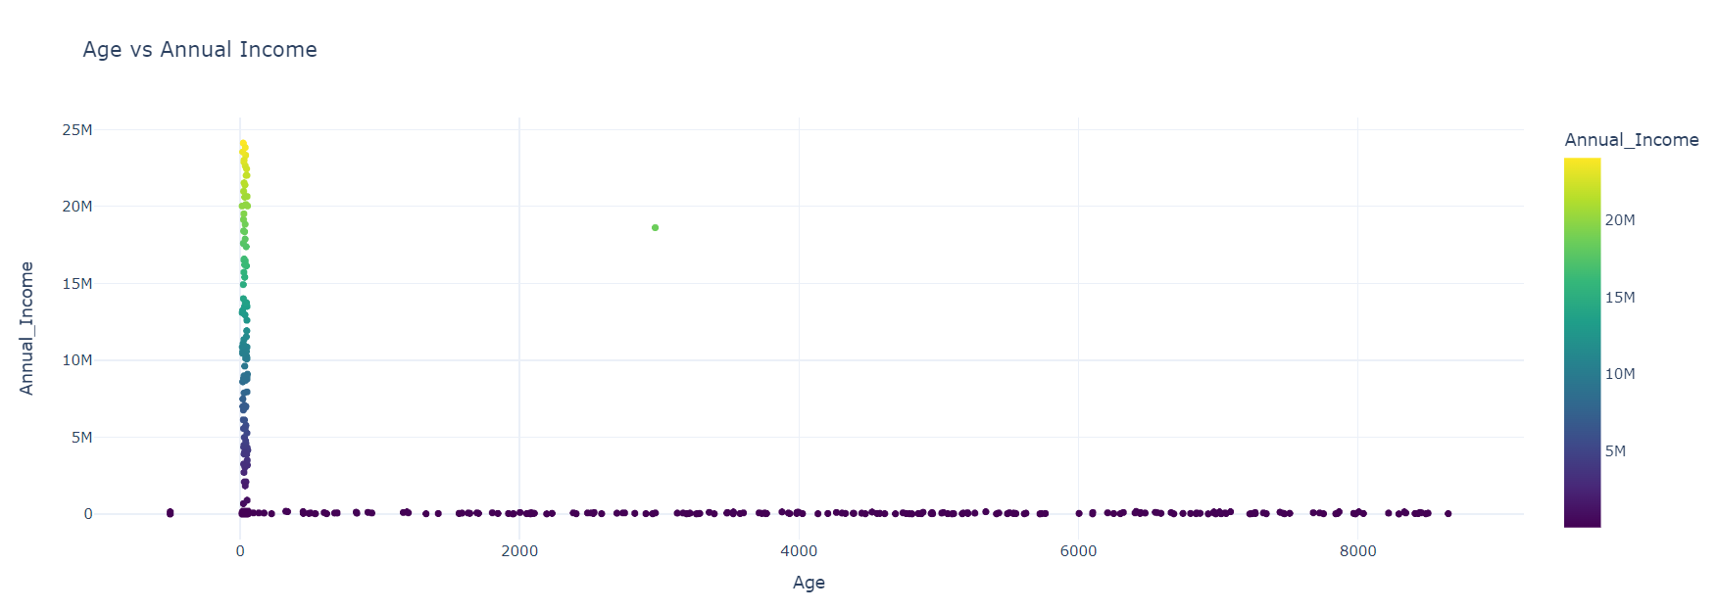

This scatter plot visualizes the relationship between age and annual income. The data points show a general upward trend, suggesting that income tends to increase with age. However, there is a wide distribution of income levels at most ages, indicating that factors other than age also significantly influence income. The plot reveals a cluster of relatively high incomes around the age of 35-45, which could correspond to peak earning years for many careers. Overall, while age appears to be positively correlated with income, there is substantial variation that cannot be solely explained by age.

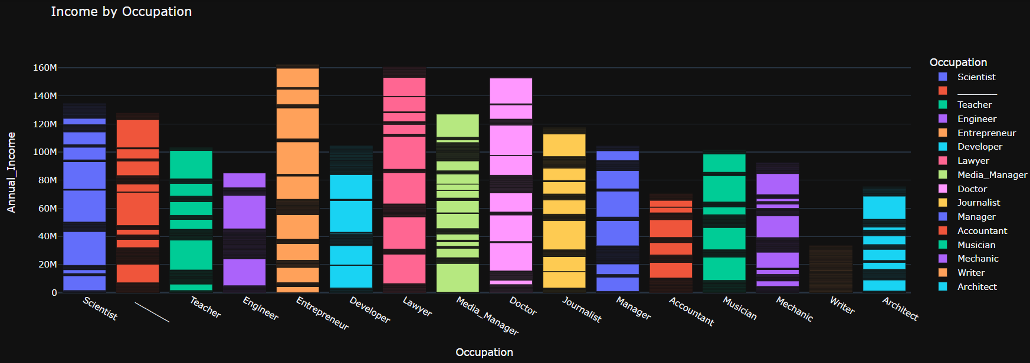

The occupations with the highest incomes appear to be Lawyer, Doctor, and Entrepreneur, while occupations like Writer, Mechanic, and Musician tend to have lower incomes. The chart highlights the significant income disparities that exist between different professions.It provides insights into the potential earning prospects associated with different career paths, although individual variations within each occupation are also expected.

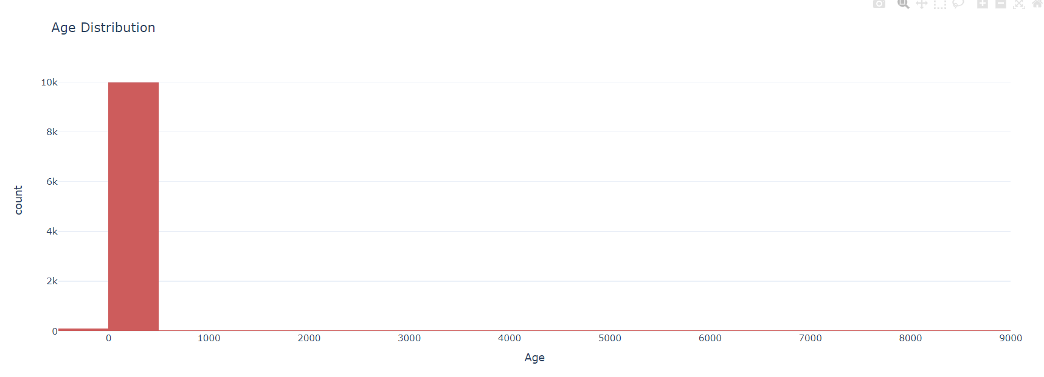

The data appears to be heavily concentrated around a single age group, forming a tall bar from approximately 6000 to 8000 on the x-axis. This suggests that the majority of the data points or individuals in the sample belong to a specific age range, potentially representing a particular demographic group or cohort. Without additional context or information about the data source, it is difficult to provide a more detailed analysis. However, the skewed distribution indicates an uneven representation across different age groups.

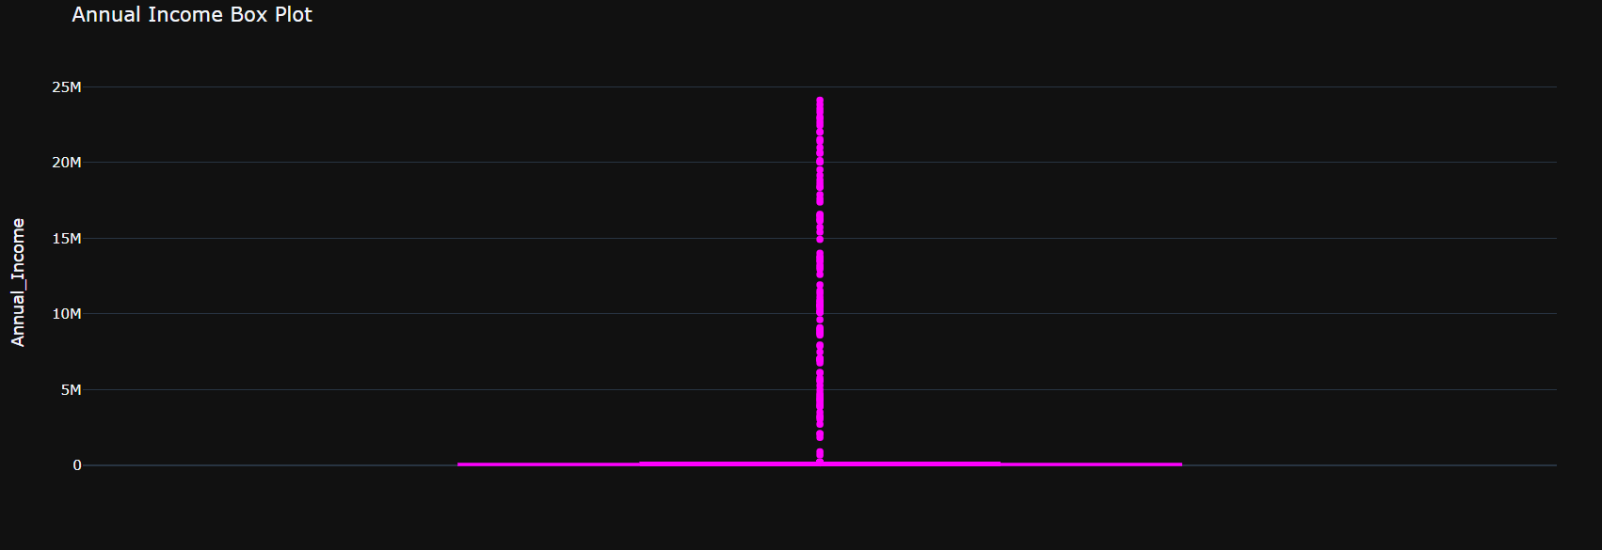

The box plot reveals a highly skewed distribution, with the majority of the data concentrated at the lower end of the income range, as indicated by the elongated box and whisker on the left side. However, there are also several outliers represented by individual points extending significantly above the main body of the data, suggesting the presence of a smaller number of very high income values. This type of distribution is common when dealing with income or wealth data, where there is a large number of lower incomes and a relatively small number of extremely high incomes, resulting in a heavily right-skewed shape.

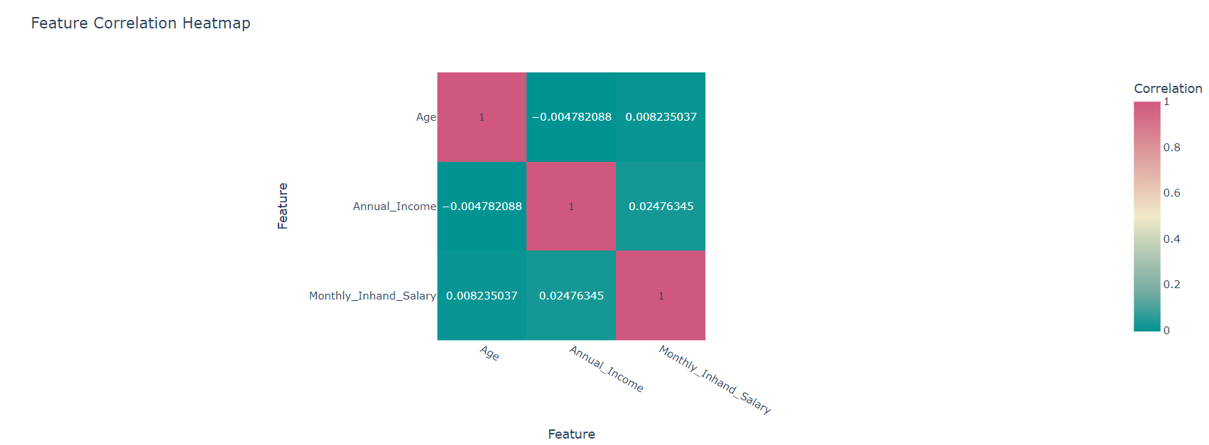

all the correlations are very weak, appearing close to 0. There is a slightly positive correlation between Monthly Inhand Salary and Annual Income (0.02476345). This means that there might be a slight tendency for people with higher monthly salaries to also have higher annual incomes, but the correlation is so weak that it may not be statistically significant. the heatmap suggests that there is very little linear relationship between these three features.